**How to get an already existing Django project running**

1. Clone the repository
2. Open the project in a code reader such as VSCode
3. Run this command in a new terminal “pip install -r requirements.txt”

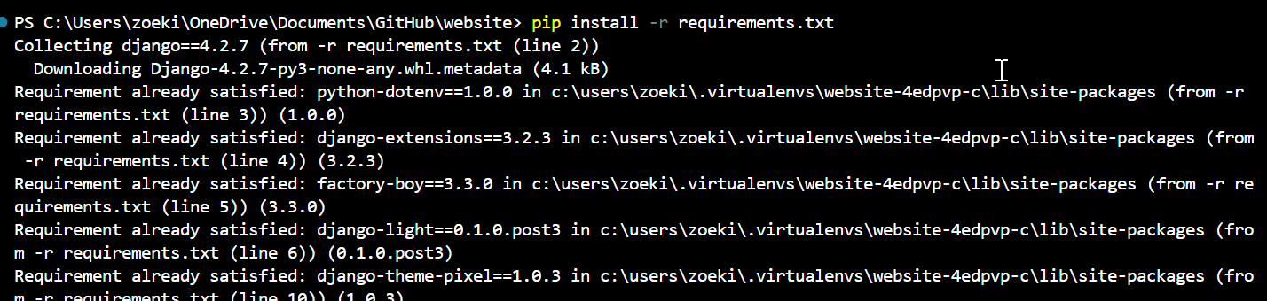

1. Then command “python manage.py runsever” which will run the project and either cntrl click on “localhost://127.0.0.1” or type into your browser address bar “localhost://127.0.0.1”

1. If there are any migrations need to be made run command “python manage.py migrate”